Deer Contest 2022
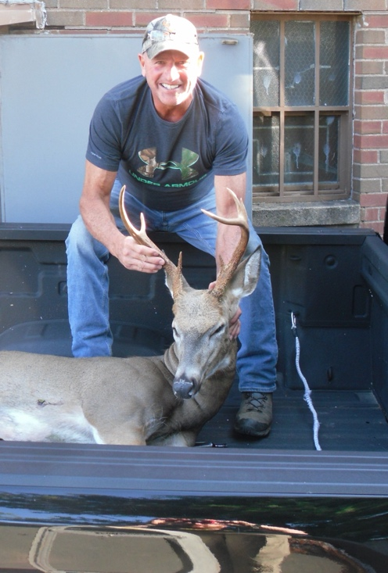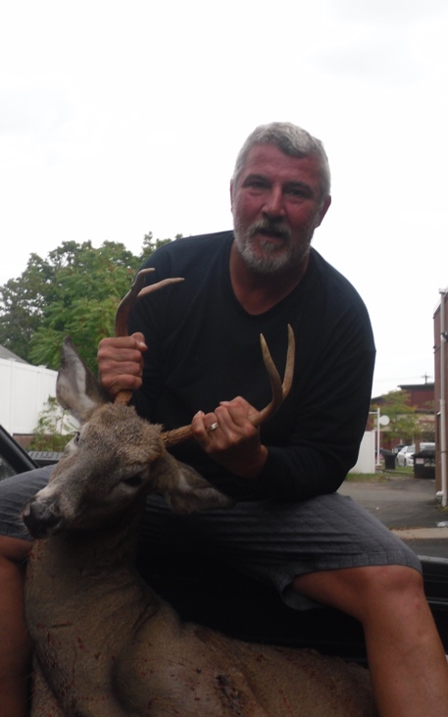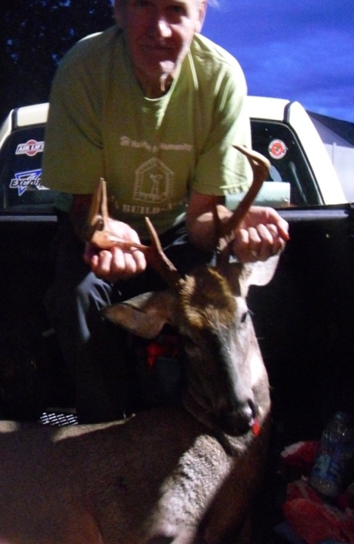
Mike Slayton 194.2 Gino Cassista 123.4 Frank Stave 140.4
7 pt. 4 Pt. 7 PT.
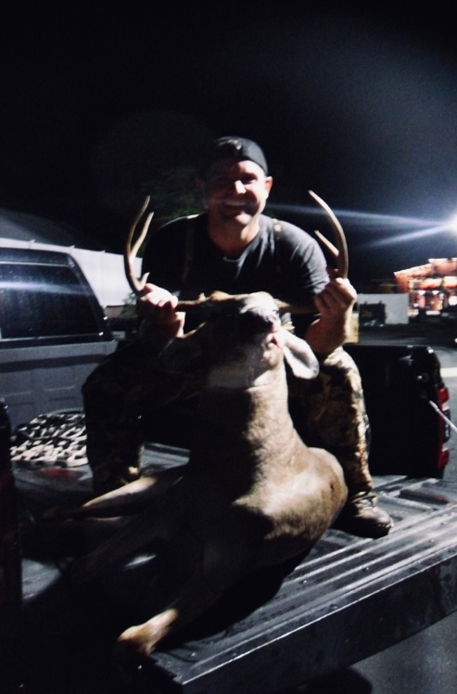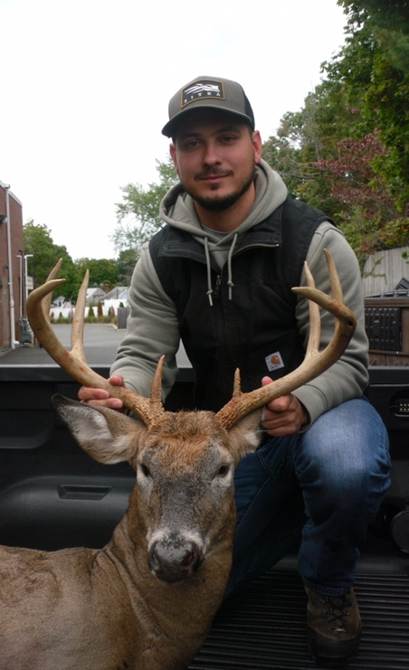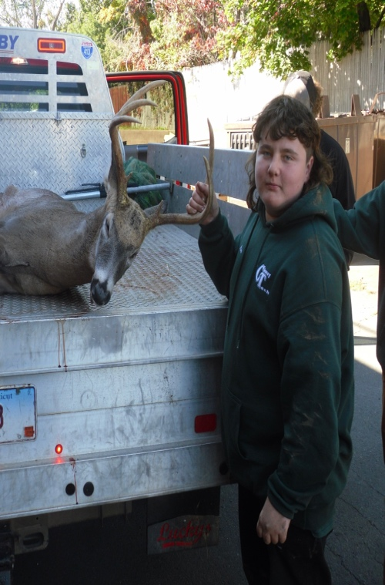
AJ ROYCE 165.6 Matt Wood 185.0 Aidan DouGan
9 PT. 8 Pt. 7 Pt. 172.00

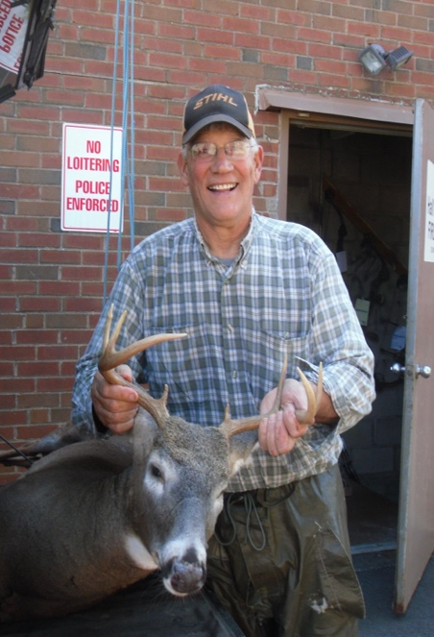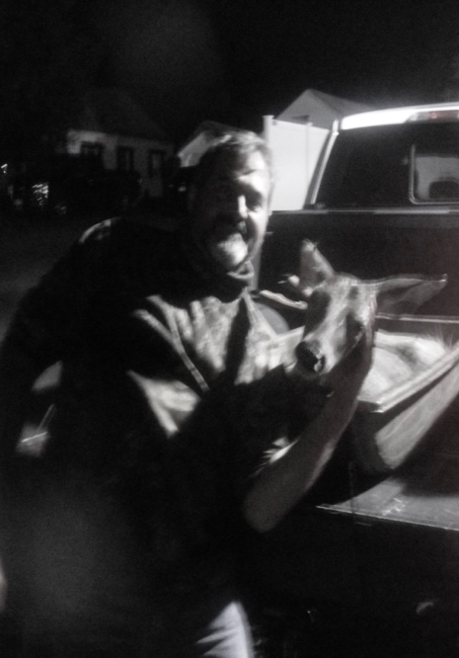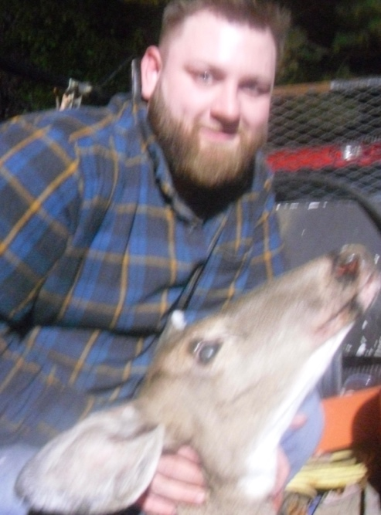
Tom Venzia Paul Arcari Buddy Gauthier
8 Pt. 154.4 DOE 103.8 DOE 112.2
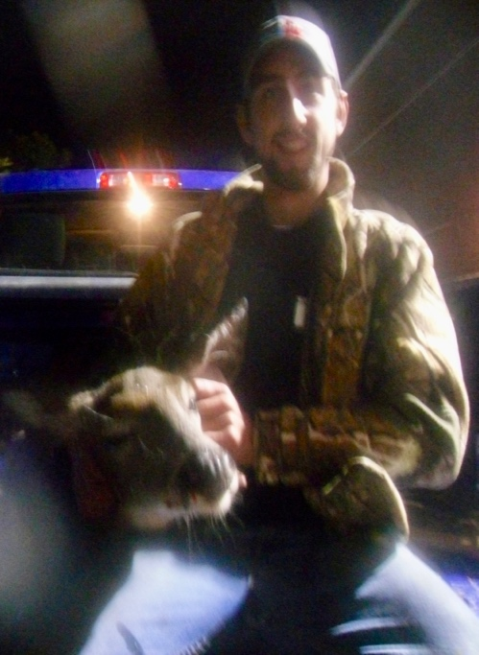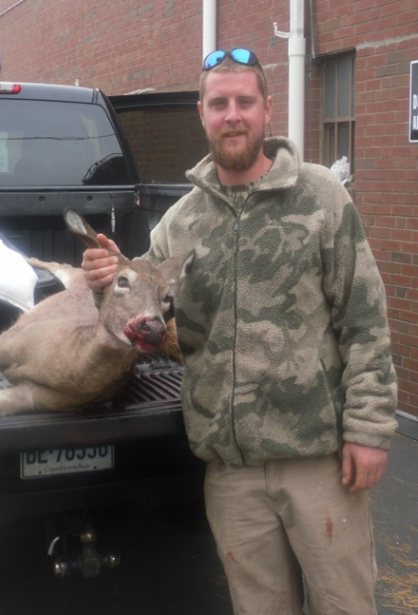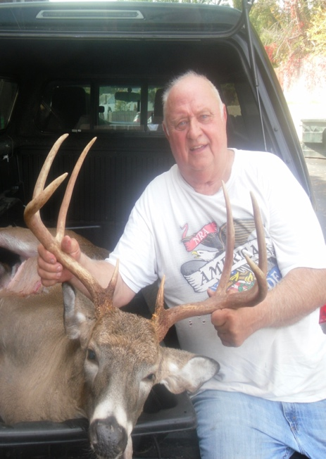
Stewart Adams Brent Luginbuhl Tom Storer
Doe 99.6 Doe 116.4 8 pt. 205.8

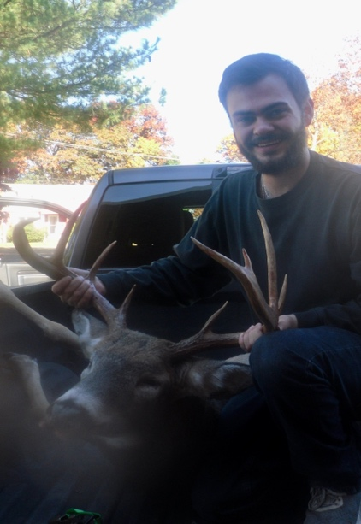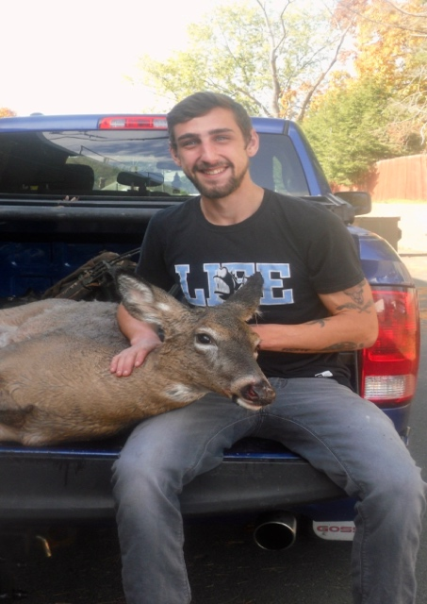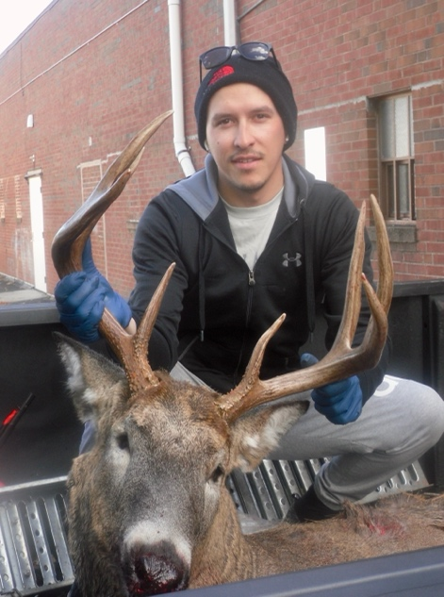
Vincent Martocchio Stweart Adams Orest Markiv
9 pt. 202.8 doe 139.6 8 pt 197.8

